Sprint 1 - Endurance Design Document

November 3, 2022

Table of Contents

1. Executive Summary 3

1.1 Project Overview 3

1.2 Purpose and Scope of this Specification 3

2. Product/Service Description 3

2.1 Product Context 3

2.2 User Characteristics 3

2.3 Assumptions 4

2.4 Constraints 4

2.5 Dependencies 4

3. Requirements 4

3.1 Functional Requirements 4

3.2 Security 4

3.2.1 Protection 4

3.2.2 Authorization and Authentication 4

3.3 Portability 5

4. Requirements Confirmation/Stakeholder sign-off 5

5. System Design 5

5.1 Algorithm 5

5.2 System Flow 6

5.3 Software 6

5.4 Hardware 7

5.5 Test Plan 7

5.6 Task List/Gantt Chart 8

5.7 Staffing Plan 8

# Executive Summary

## Project Overview

The robot will travel in a rectangle (following the circumference of the blue tape) on the ground in Howard Hall room 208. The robot will light up specific colors and speak while staying along the tape placed on the ground. The robot will complete these tasks by running through the code assigned to it.

## Purpose and Scope of this Specification

The Purpose of this project is for the robot to successfully travel along the blue tape on floor of room 208 in Howard Hall.

In scope

The following items are in scope:

* The Sphero robot follows along the blue tape placed on the floor throughout the entire process
* The Sphero robot the correct color assigned to it per the code in the beginning and at the end of the process
* The Sphero robot speaks when it has been programmed to
* The Sphero robot speaks what it has been programmed to

Out of Scope

The following items are out of scope:

* + When the Sphero Robot does not follow along the blue tape placed on the floor throughout the entire program
  + When the Sphero robot does not change to the correct color assigned to it per the code in the beginning and at the end of the process
  + When the Sphero robot does not speak when it has been programmed to
  + When the Sphero robot does not speak what it has been programmed to

# Product/Service Description

* This Project is an assignment for *Intro to Problem Solving* (CS 104-01)
* Sprint #1 – Endurance is due 11:59, November 3, 2022

## Product Context

* Sprint 1 (Endurance) is independent
  + One part of a triathlon
* Connected to a larger project consisting of three parts but Sprint 1 is independent
* Sprint 1 is Endurance, Sprint 2 is Accuracy, Sprint 3 is Agility
* Three group members working collaboratively on all three parts of the project

## User Characteristics

1. Students taking the CS 104-01 course
   * Maximum of 2 or fewer years of computing experience
   * First time using / testing Sphero robot / block code
2. Professor of CS 104-01 course
   * Decades of computing experience
   * Is familiar with the Sphero robot application and the block code

## Assumptions

The robot is assumed to work and perform functions when it is programmed to do so. The block code is assumed to program the Sphero robot to perform as needed. All team members are assumed to be available at the same time to work cooperatively and collaboratively on all parts of the project. All team members are assumed to complete the individual work assigned to them per the Gantt chart. Howard Hall room 208 is assumed to be available when needed.

## Constraints

* Functionality / operation of the Sphero robot
* The blue tape on the ground
* Access to Howard Hall room 128
* Availability of all group members
* Sphero robot application

## Dependencies

* The process must take place in Howard Hall Room 128
* All team members must be available to work cooperatively and collaboratively
* The Sphero Application must be used to control the robot

# Requirements

## Functional Requirements

| Req# | Requirement | Comments | Priority | Date Reviewed | SME Reviewed / Approved |
| --- | --- | --- | --- | --- | --- |
| **ENDUR_01** | The robot correctly turns at each of the three corners | Important for robot to correctly turn at each corner of the robot will not be able to complete the run through | 1 | 11/2/22 | Manar |
| **ENDUR_02** | Robot moves along blue tape in a rectangle pattern and then returns back to its starting location. | Very important, the robot moving along the blue tape will ensure a huge part of credit given. | 2 | 11/2/22 | Manar |
| **ENDUR_03** | At the start and the end of the program, the robot says the necessary statements. At the start and end of the program, the color of the robot changes. | Very important, this step is necessary for full credit, not difficult to add into block code once first and second priorities are met | 3 | 11/2/22 | Manar |

## Security

A password is necessary to gain access to the computer which contains the block code for the Sphero Robot

### Protection

* GitHub account, username, and password to access the GitHub repository
* Account username and password for the Sphero.edu account
* Sphero robot kept in safety container when not in use
* Sphero robot frequently charged to perform block code
* Email account with Sphero that has been authenticated

### Authorization and Authentication

A Sphero account with an authenticated email address is necessary

## Portability

* Sphero block code is absolutely host dependent
* Access to the Sphero block code and control of the Sphero robot can be accessed by computer or any mobile device

# Requirements Confirmation/Stakeholder sign-off

Include documentation of the approval or confirmation of the requirements here. For example:

|  |  |  |
| --- | --- | --- |
| Meeting Date | Attendees (name and role) | Comments |
| 11/03/2022 | Sean, Anthony, Manar | confirmed all except ENDUR_XX |
| MM/DD/YY | My group member names | confirmed…………. |

# System Design

## Algorithm

Develop and describe here the algorithm that will be used to provide the required performance of your software:

*#Preliminary Steps*

* Place robot on starting point (Corner 1)
* Aim robot so that the blue light is facing you along the first line
* Start Program
* Enable Stabilization
* Change main LED colors to green
* Speak the line “Ready, Set, Go!” and wait

*#Movement: Line 1*

* Roll along the first line at 0 degrees with a speed of 79 speed for 8.5 seconds
* Stop at the second corner
* Wait in place for 3 seconds

*#Movement: Line 2*

* Roll along the second line at 90 degrees at 75 speed for 5 seconds
* Stop at the third corner
* Wait in place for 3 seconds

*#Movement: Line 3*

* Roll along the third line at 180 degrees with a speed of 75 for 5 seconds
* Stop at the fourth corner
* Wait in place for 3 seconds

*#Movement: Line 4*

* Roll along the fourth line at 270 degrees at 75 speed for 5 seconds
* Stop at the starting point
* Wait in place for 3 seconds

*#Program Termination*

* Change main LED colors to red
* Speak the line “I’m done, and I need water!”
* Terminate program

## System Flow

Develop a flowchart (and show here) that accurately depicts how your software application will act to fulfill the algorithm

## Software

Describe software languages/platforms/APIs used to develop and deploy this application:

* The Sphero application is required to develop the block code necessary to allow the robot to perform functions. This application is available for download on most common operating systems (in terms of computers) and app stores (in terms of mobile devices). However, it *must* be done on an apple-developed operating system (Mac OS or iOS) in order to obtain the sensor data.
* Executable programs are developed using in-app block code. This consists of function-templates with modifiable values.

## Hardware

Several hardware platforms were used to develop, test, and demonstrate this application. These include:

* LG Laptop (Windows OS) – For development
* MacBook Pro (Mac OS) – For development
* iPhone (iOS) – For development and retrieval of sensor data
* Sphero Robot – For demonstrating program
* Bluetooth – Sphero robot executed code wirelessly

## Test Plan

| **Reason for Test Case** | **Test Date** | **Expected Output** | **Observed Output** | **Staff Name** | **Pass/Fail** |
| --- | --- | --- | --- | --- | --- |
| 1. aim of robot | 11/1 | For robot to go straight | Robot did not go straight | Manar | Fail |
| 1. aim of robot | 11/1 | For robot to go straight | Robot did not go straight | Anthony | Fail |
| 1. aim of robot | 11/1 | For robot to go straight | Robot did go straight | Sean | Pass |
| 1. aim of robot | 11/1 | For robot to travel straight along blue tape | Robot did not travel straight along blue tape | Anthony | Fail |
| 1. aim of robot | 11/1 | For robot to travel straight along blue tape | Robot did travel straight along blue tape | Manar | Pass |
| 1. distance of robot | 11/1 | For robot to successfully stop at the end of the first line | Robot overran end of the first line | Sean | Fail |
| 1. distance of robot | 11/1 | For robot to successfully stop at the end of the first line | Robot ran short of the end of the first line | Anthony | Fail |
| 1. distance of robot | 11/1 | For robot to successfully stop at the end of the first line | Robot successfully stopped at the end of the first line | Sean | Pass |
| 1. First corner | 11/1 | For robot to successfully turn the first corner | Robot went straight | Anthony | Fail |
| 1. First corner | 11/1 | For robot to successfully turn the first corner | robot successfully turned the first corner | Manar | Pass |
| 1. Second corner | 11/1 | For robot to successfully turn the second corner | robot successfully turned the second corner | Sean | Pass |
| 1. Third Corner | 11/1 | For robot to successfully turn the third corner | robot overran the third corner | Manar | Fail |
| 1. Third Corner | 11/1 | For robot to successfully turn the third corner | robot successfully turned the third corner | Anthony | Pass |
| 1. Full run | 11/1 | For robot to complete the full run on the line | Robot did not complete the full run on the line | Manar | Fail |
| 1. Full run | 11/1 | For robot to complete the full run on the line | Robot completed the full run on the line | Sean | Pass |

## Task List/Gantt Chart

Embed your Gantt chart here:

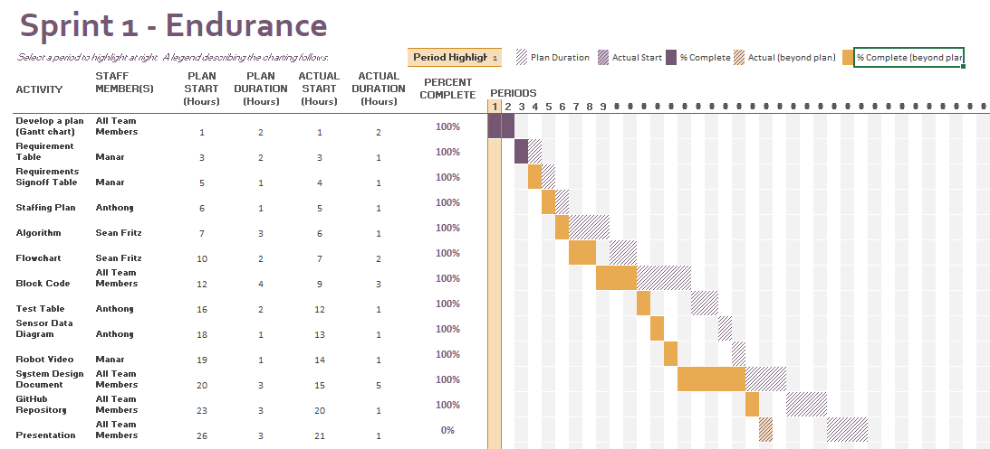

Gantt Chart Excel file available for download below:

[[https://drive.proton.me/urls/BGXBHM7XH0#HneLT4cZFhAM]](https://drive.proton.me/urls/BGXBHM7XH0%23HneLT4cZFhAM%5d)

## Staffing Plan

Insert a chart/table that depicts the roles and responsibilities of each team member that worked on this project

| Name | Role | Responsibility | Reports To |
| --- | --- | --- | --- |
| Sean | Planner, Coordinator | Coder, Algorithm, flowchart | Anthony, Manar |
| Anthony | Organizer, tester | Test table, sensor data, staffing plan | Sean, Manar |
| Manar | Documenter, tester | Videographer, system design document | Sean, Anthony |